Enterprise Application Development – AI
- Created Confluence page using vibe coding
- Created .md files and started uploading pages into the confluence .
- Provide required confluence api keys ,space information ,api keys created with the scopes
- Calling confluence api for uploading the pages
Prompt below used to conver .md files to documents -> it created .html files under ouputs/a.html for each .md file . Once it is generated it will upload all pages to confluence via OAuth.
You are a banking documentation assistant.

Convert the following Markdown into Confluence-ready documentation.

Enhance structure if needed:
- Add missing sections (Overview, Architecture, APIs, Business Rules)
- Keep banking domain accuracy
- Maintain professional enterprise tone
- Output must be Confluence storage format compatible HTML

Markdown content:
{md_file_content}

You are a banking documentation assistant.

Convert the following Markdown into Confluence-ready documentation.

Enhance structure if needed:
- Add missing sections (Overview, Architecture, APIs, Business Rules)
- Keep banking domain accuracy
- Maintain professional enterprise tone
- Output must be Confluence storage format compatible HTML

Markdown content:
{md_file_content}
- 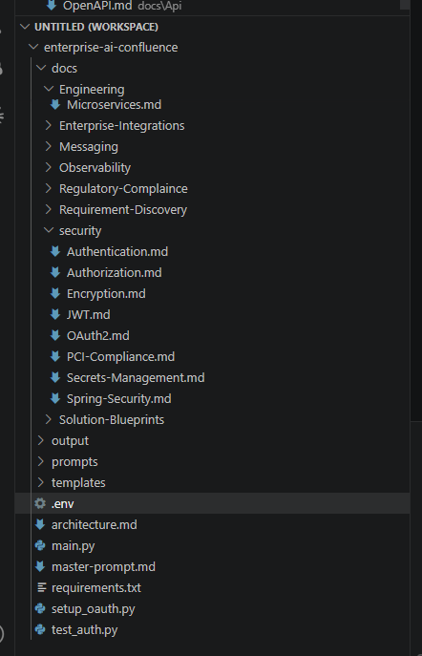
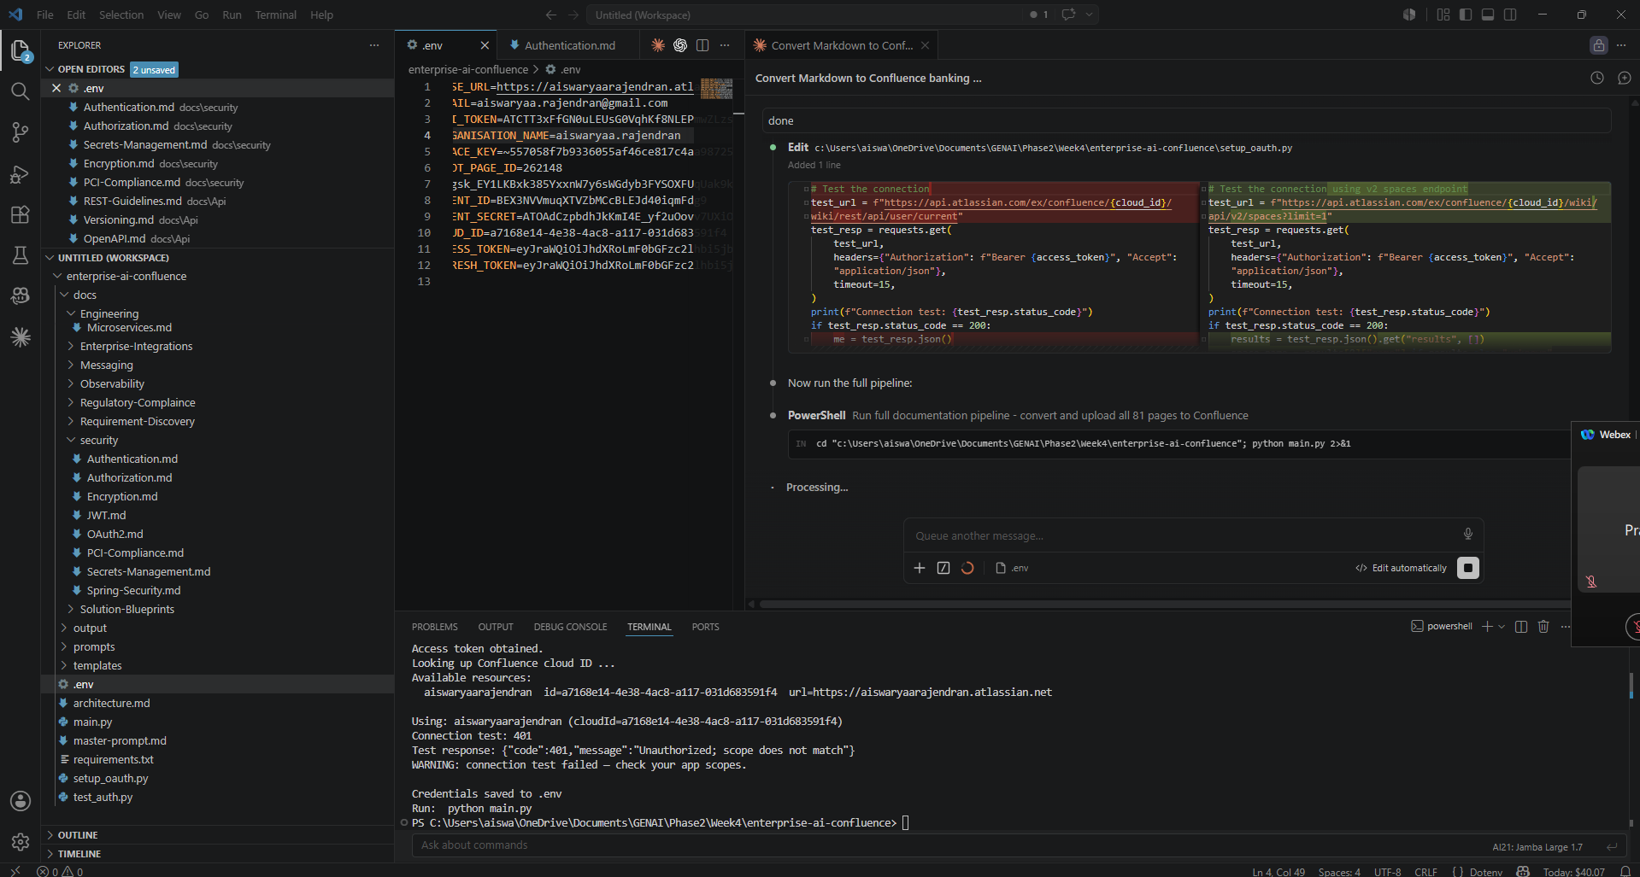
Make sure we have right scope added to api key and enable oAuth app
Go to your OAuth app in Atlassian Developer Console
- Open: https://developer.atlassian.com/console/myapps/
- Click your app "Confluence Uploader"
- Go to "Permissions" → "Confluence API" → "Edit Scopes"
- Add / enable these granular scopes:
- read:page:confluence
- write:page:confluence
- read:space:confluence
(Keep offline_access too)
- Save

Confluence page verification:
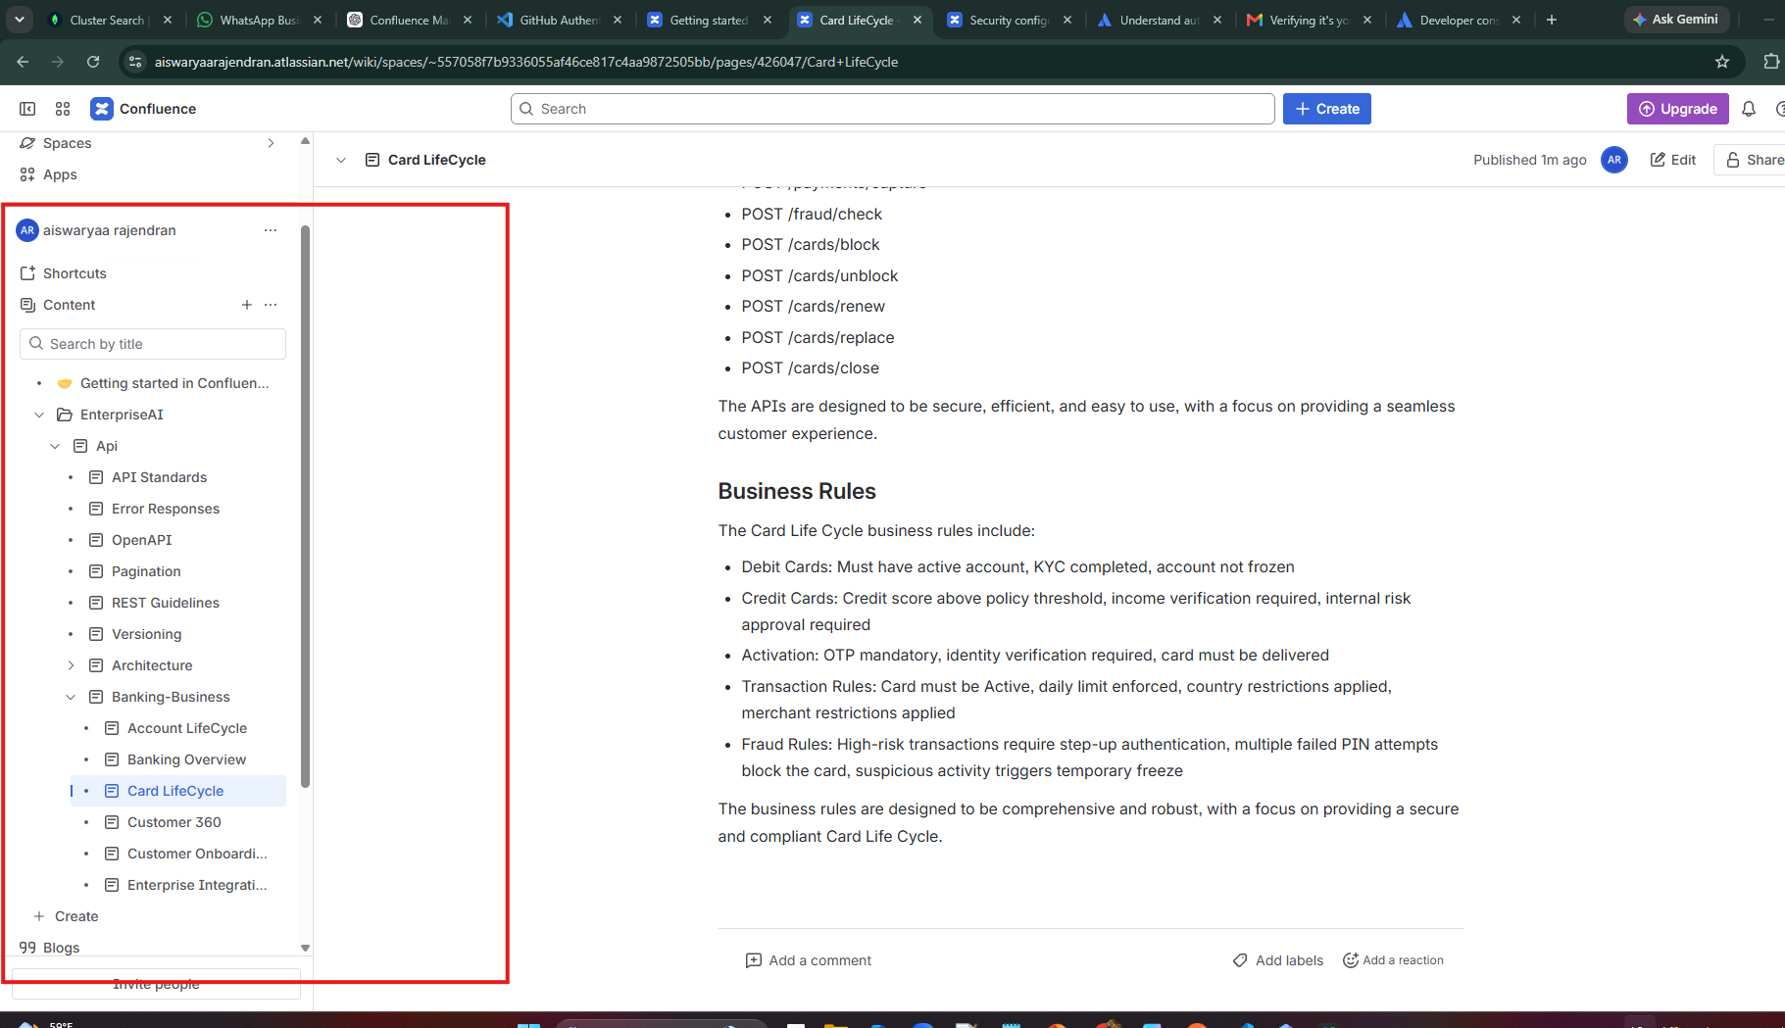

- Created .md files placed under project/docs/
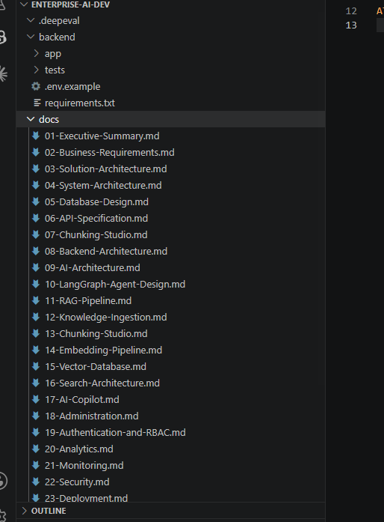
- Create Backend front end development by using the generated prompt using chatgpt

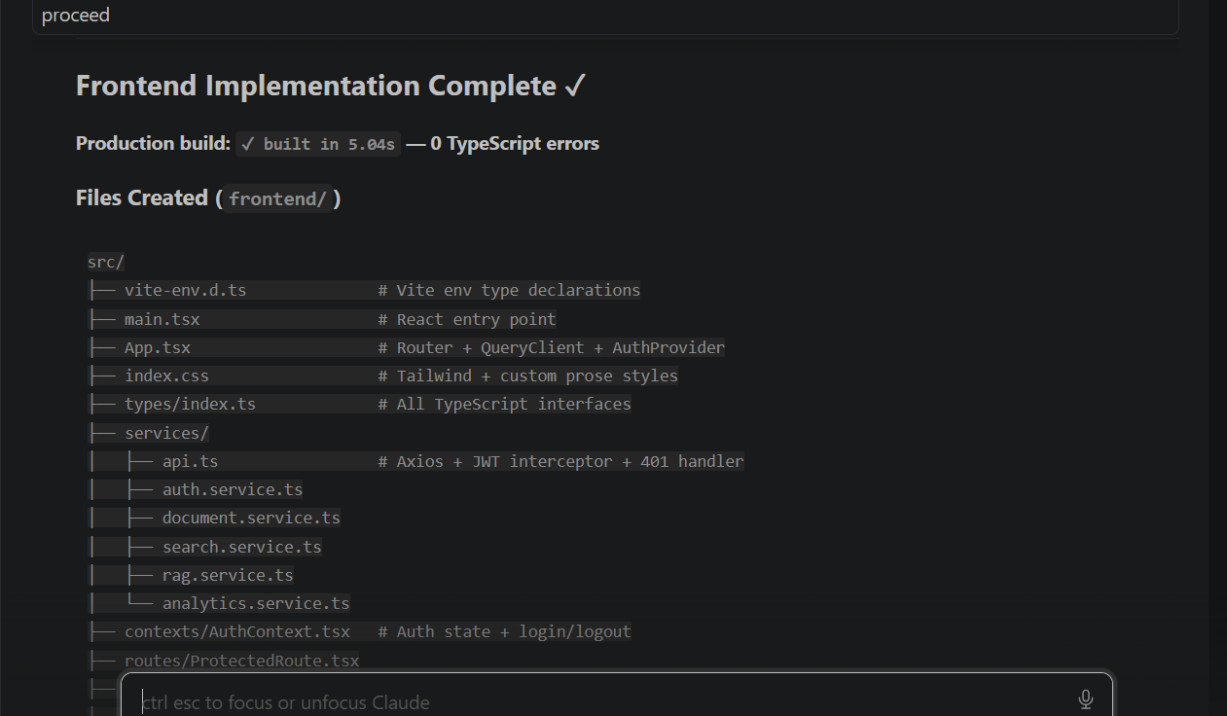

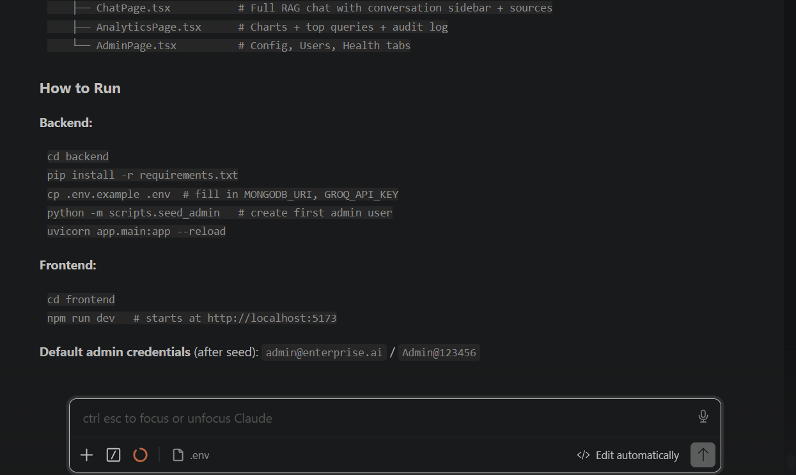

Confluence Page :
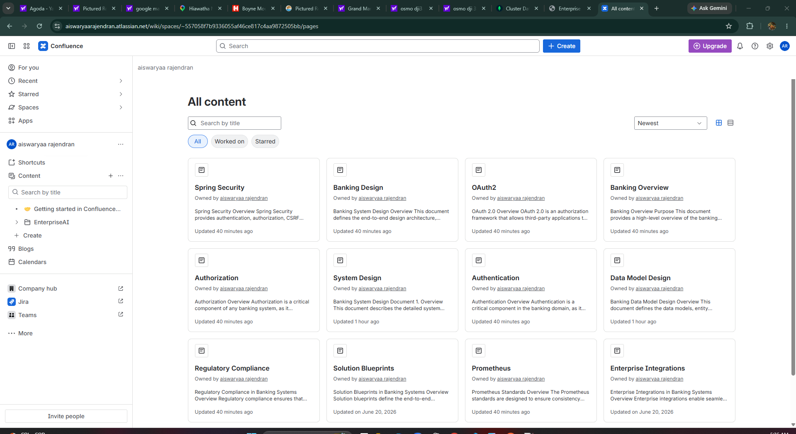

Start backend and front end

admin@enterprise.ai / Admin@123456 – After login to application

Dashboard : Has details of documents , searches ,users details

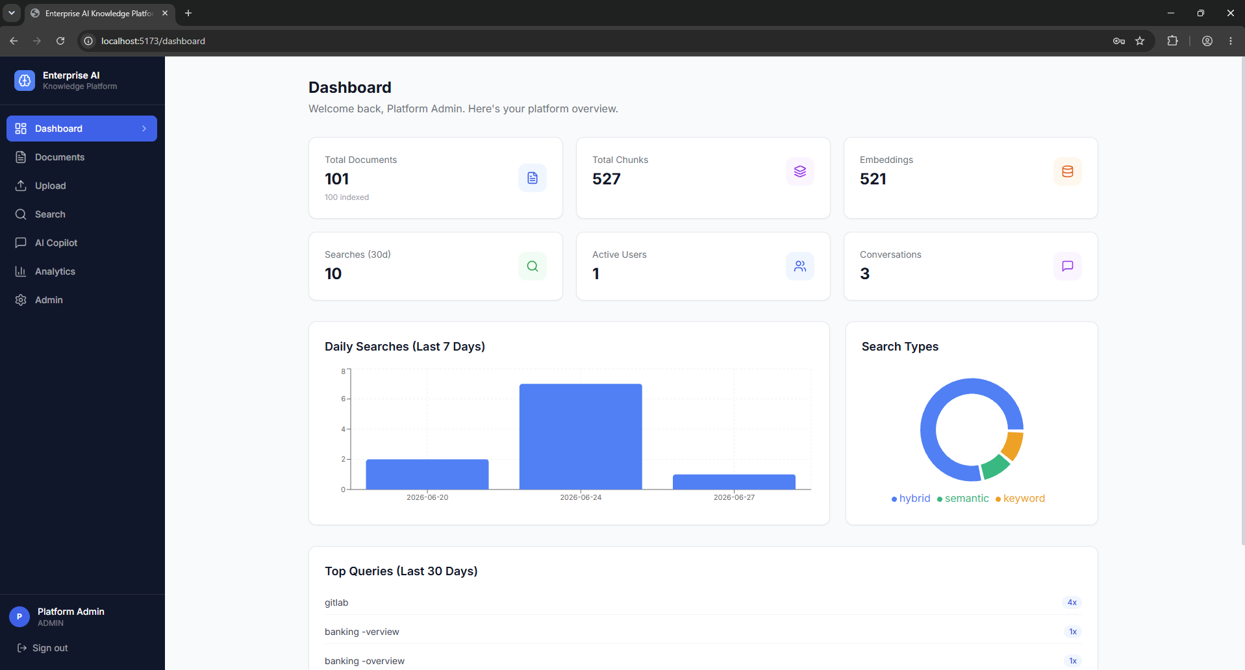
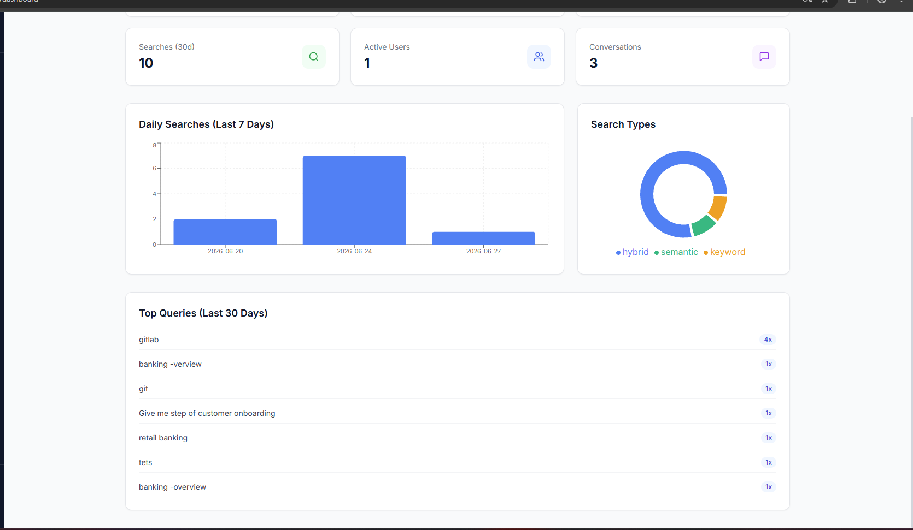

Clicks on documents -> search result click preview icon – shows up
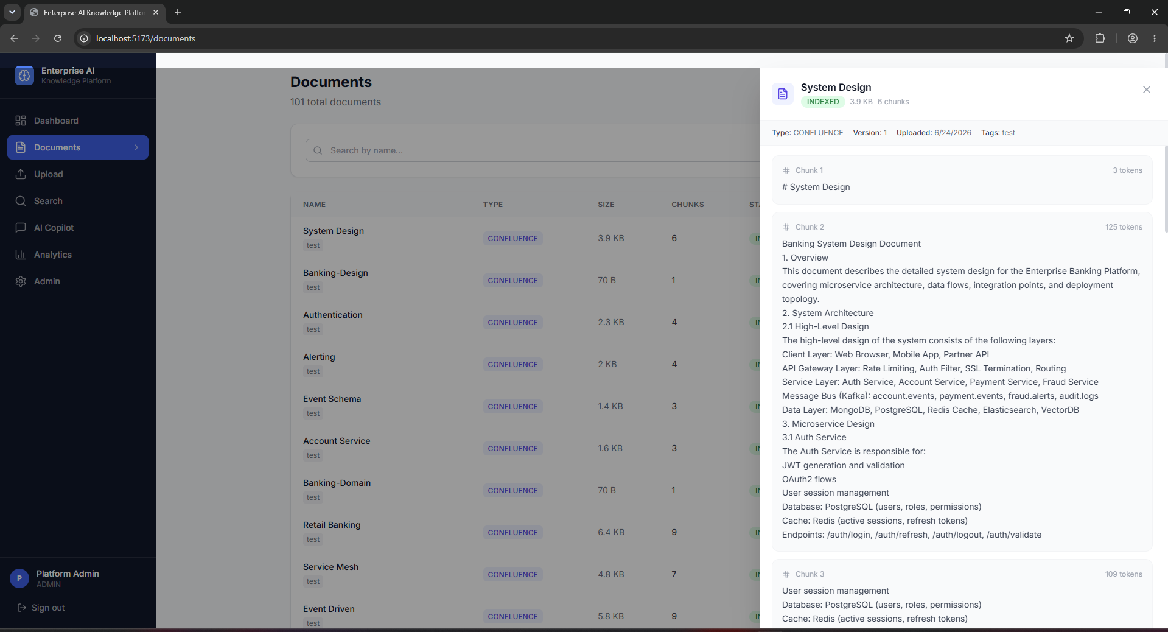

Upload :
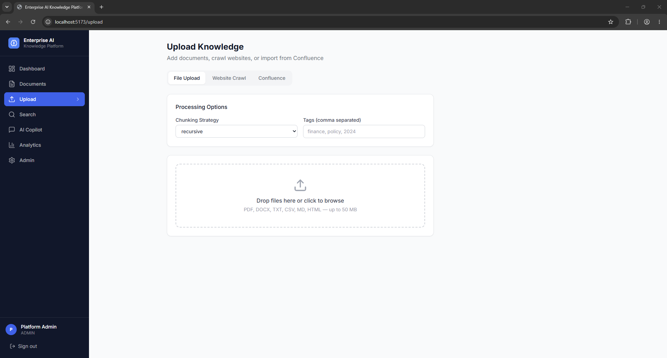

Clicks on Confluence and provide page information -> it will start creating chunks and embedding store it into db.
https://aiswaryaarajendran.atlassian.net/wiki/spaces/~557058f7b9336055af46ce817c4aa9872505bb/overview?atl_f=PAGETREE
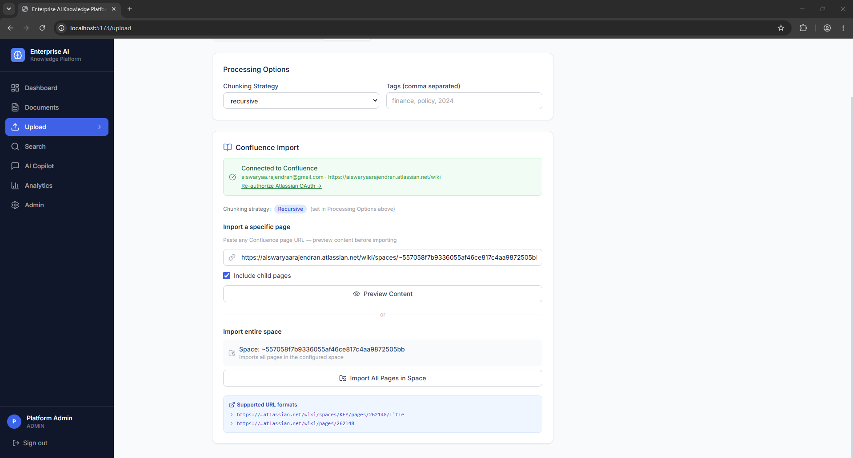
Clicks on Preview content opens up the list of pages fetched from confluence

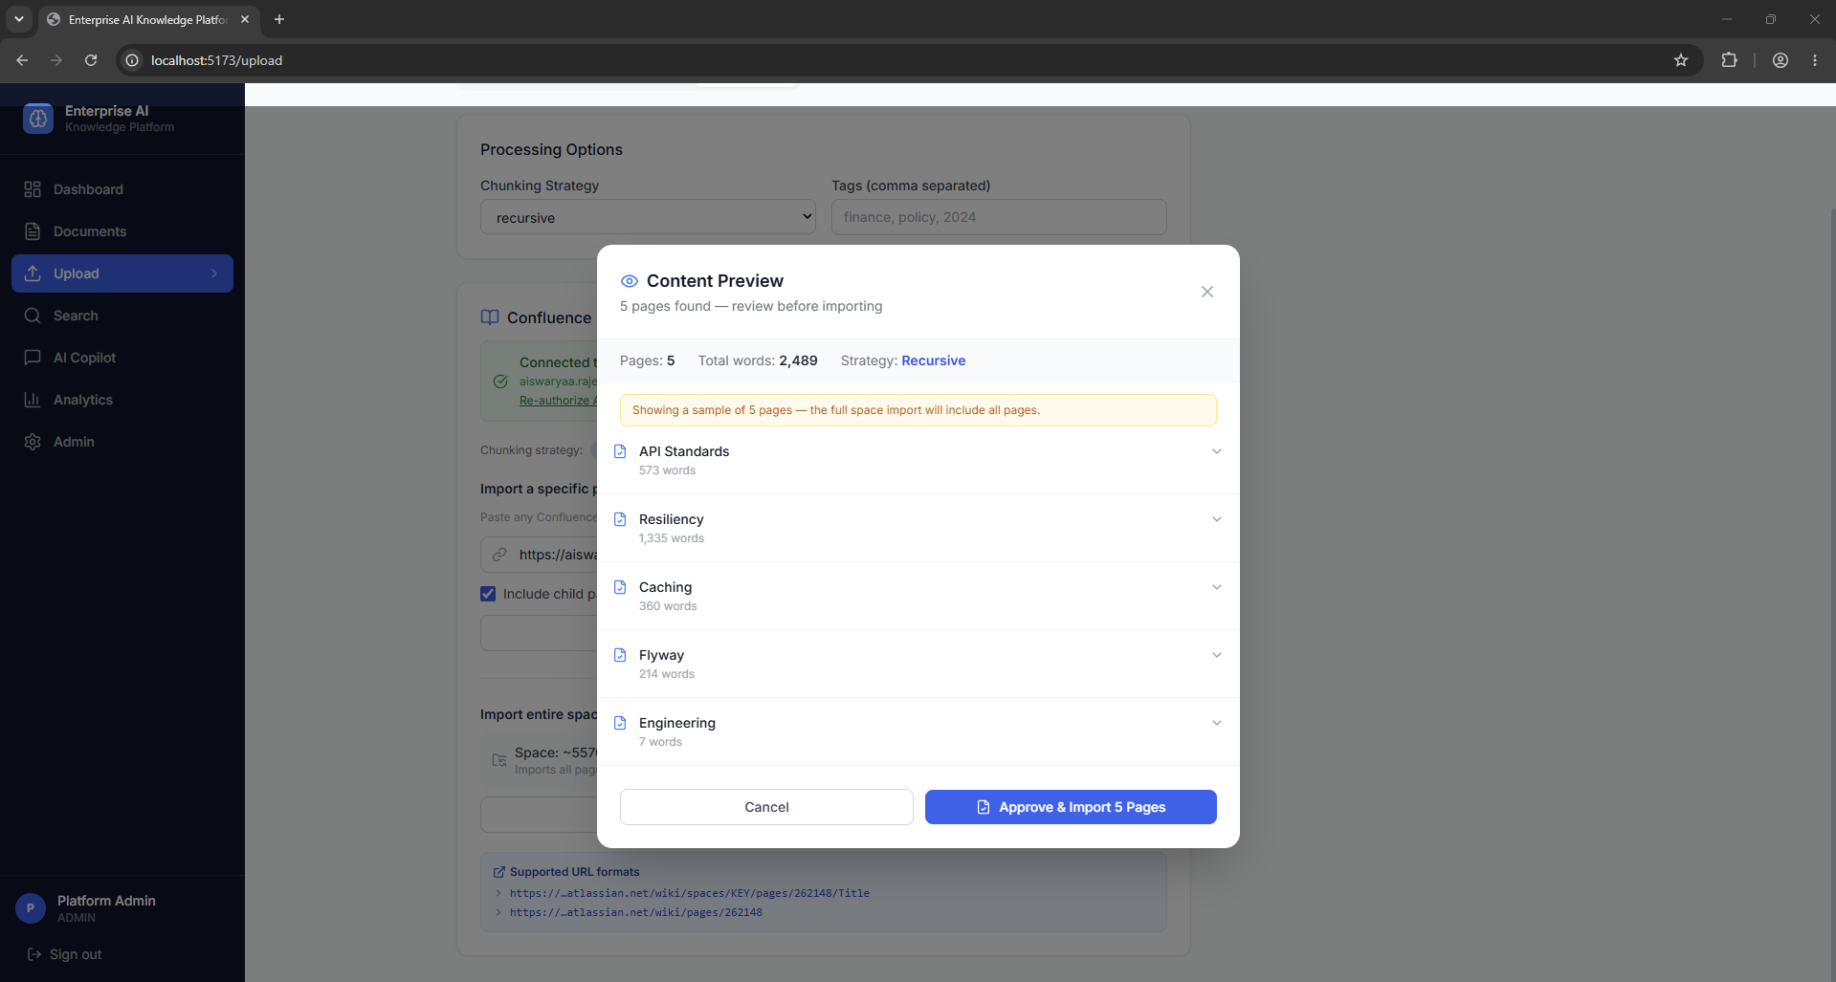
If user clicks approve it will approve and upload documents with embedding in mongo db .
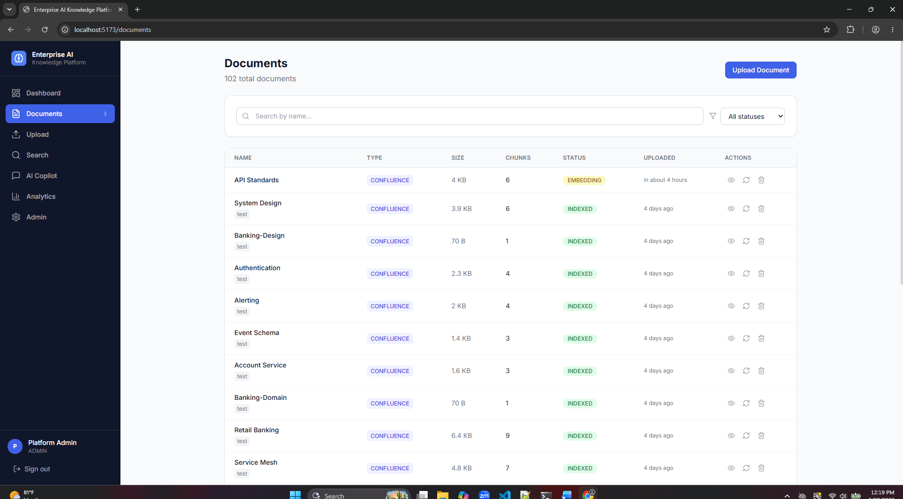

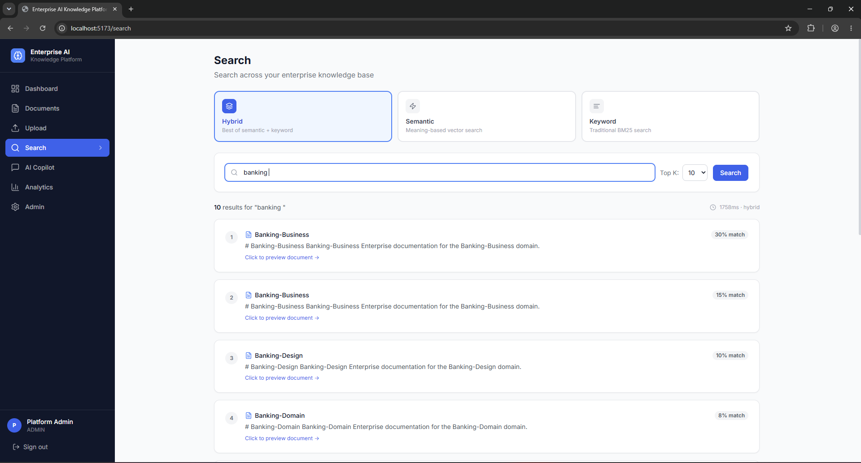
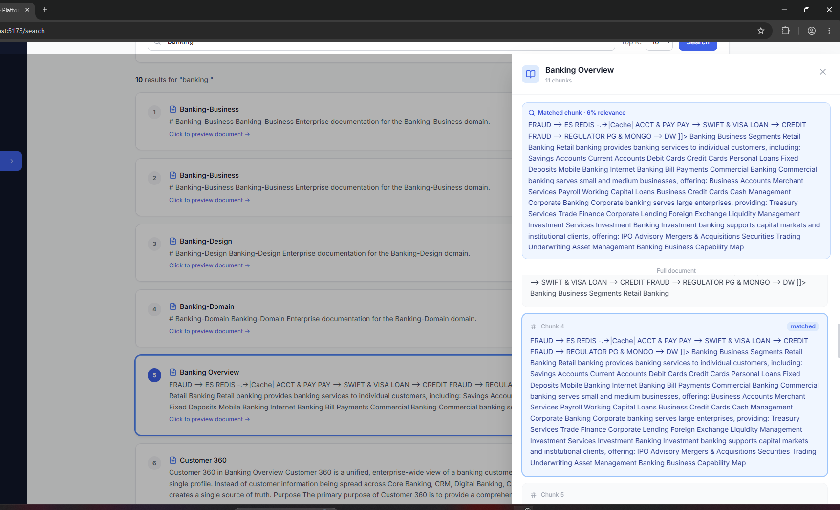
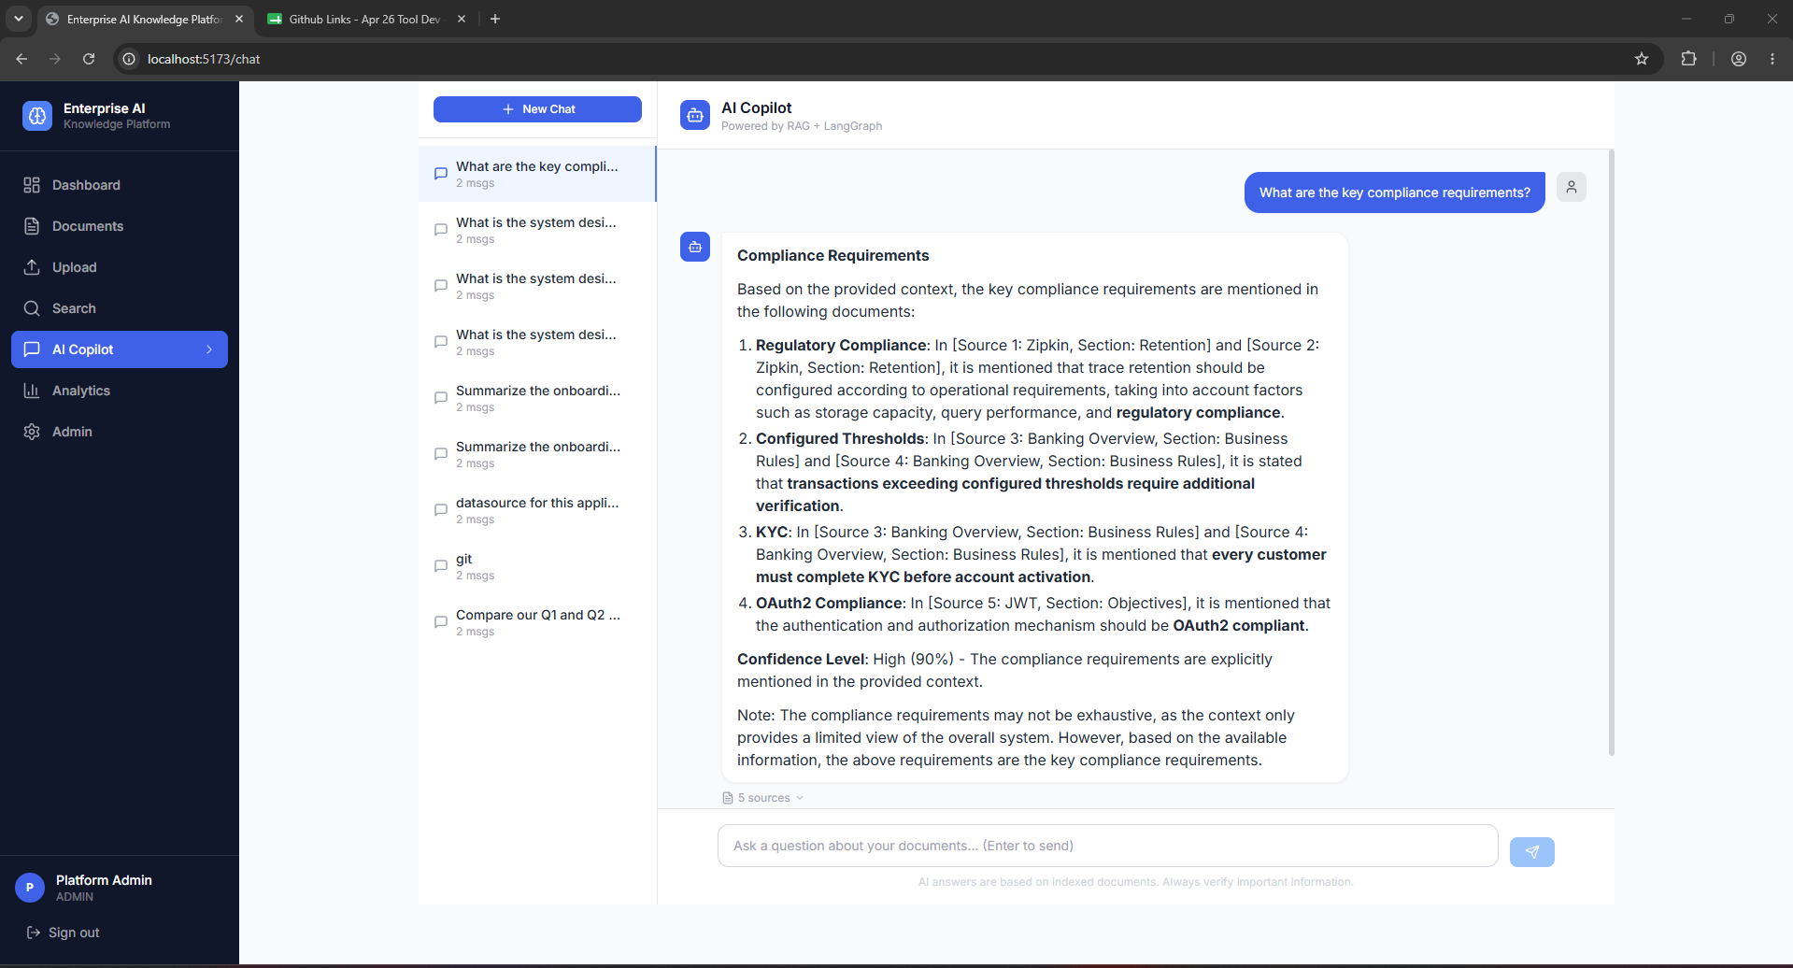

AI Copilot - Results above

Analytics – having details of search history
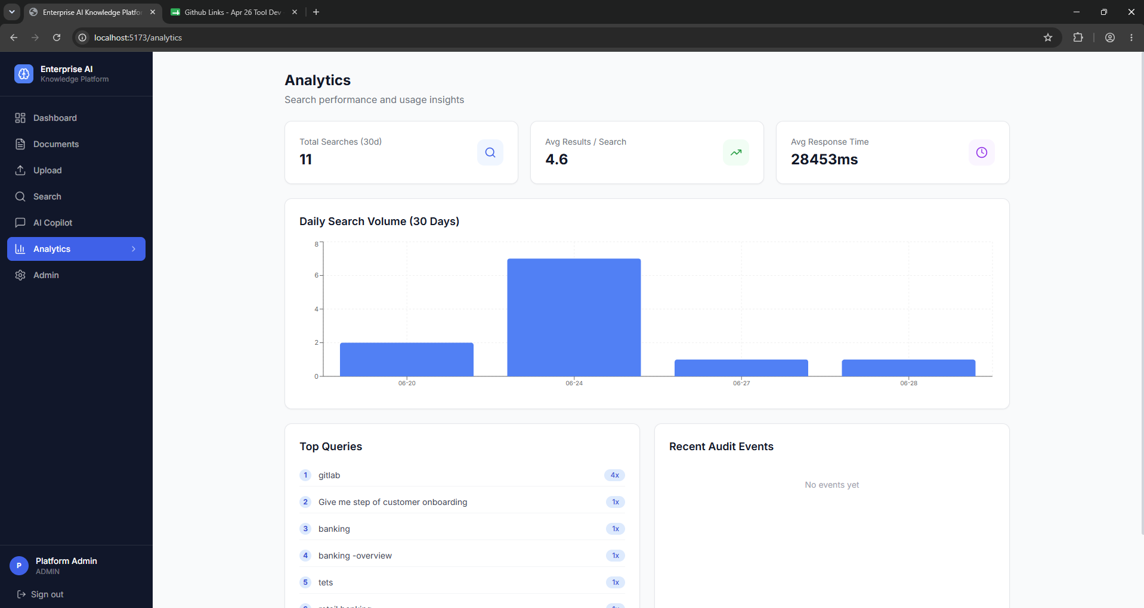

Admin tab :

Clicks on Add user – has the ability to add user with the permission
